VPFO Email Signature Guide

October 24, 2019

OUR INTENTION:*email signatures are one easy way we can all show that we are part of the VPFO and UBC while being professional, helpful to others, and supporting the UBC common look and feel guidelines. This document gives both a standard template and some examples of special cases. While we can’t image every special case, the guide should help you on the right path to representing yourself, the VPFO, and UBC.*

## Introduction

In line with the launch of the VPFO Strategic Plan, all portfolio team members are encouraged to update their email signatures to align with the official UBC templates. It’s important to adhere to the UBC brand and maintain a common look and feel, both across UBC and our portfolio. Small touches like this help to connect you to the university and bring members of the VPFO together, and only take a few minutes to set up.

You should have two email signatures set up, a long one for new emails, and a short one for replies/forwards. This helps to save time by including contact information in every email without making email chains too long.

There is no “correct answer” for email signatures, but there are things you should avoid. Use the below examples to inform how you structure your signature and try not to add any additional or custom aspects to it, for example specific project information or charitable causes. Copy and paste whichever template elements are most applicable to you and amend the details as necessary.

## Support

If you are unsure about how or whether you should include something in your email signature, consult the [UBC brand guidelines](https://brand.ubc.ca/guidelines/downloads/email-signatures/), or contact Alfie Penfold at [alfie.penfold@ubc.ca](mailto:alfie.penfold@ubc.ca) or 604.440.1977. If you would like advice on how to approach communications for a project or initiative you’re working on, visit the [Communications & Engagement page on the VPFO website](https://vpfo.ubc.ca/departments/ancillary/vpfo-communications-engagement/) or get in touch with your local VPFO Communications & Engagement team member.

## Templates

|  |
| --- |
| Generic VPFO long signature (for new emails) |
| **FirstName LastName** QUALIFICATIONS Job Title  VP Finance & Operations (VPFO) Portfolio  The University of British Columbia | Vancouver Campus | Musqueam Traditional Territory Building | Street Address  Vancouver BC | Postcode | Canada Phone XXX.XXX.XXXX | Cell XXX.XXX.XXXX  [email.address@ubc.ca](mailto:email.address@ubc.ca) | vpfo.ubc.ca | local website (e.g. [srs.ubc.ca](http://www.srs.ubc.ca))  UBC E-mail Signature |

|  |
| --- |
| Generic VPFO short signature (for replies/forwards) |
| **FirstName LastName** QUALIFICATIONS  Job Title  VP Finance & Operations (VPFO) Portfolio | The University of British Columbia  Phone XXX.XXX.XXXX | Cell XXX.XXX.XXXX |

|  |
| --- |
| Detailed department long signature - (choose fields as appropriate) |
| **FirstName LastName** QUALIFICATIONS Job Title  VP Finance & Operations (VPFO) Portfolio | AVP Group | Department | Unit | Team  The University of British Columbia | Vancouver Campus | Musqueam Traditional Territory Building | Street Address  Vancouver BC | Postcode | Canada Phone XXX.XXX.XXXX | Cell XXX.XXX.XXXX  [email.address@ubc.ca](mailto:email.address@ubc.ca) | vpfo.ubc.ca | group website (e.g. [facilities.ubc.ca](http://www.facilities.ubc.ca/)) | local website (e.g. [srs.ubc.ca](http://www.srs.ubc.ca))  UBC E-mail Signature  **Example**  **John Smith** MA Team Manager  VP Finance & Operations (VPFO) Portfolio | Facilities | Building Operations | Municipal Services | Hard Landscape  The University of British Columbia | Vancouver Campus | Musqueam Traditional Territory University Services Building | 2329 West Mall  Vancouver BC | V6T 1Z4 | Canada Phone 111.222.3333 | Cell 444.555.6666 [john.smith@ubc.ca](mailto:john.smith@ubc.ca) | vpfo.ubc.ca | [facilities.ubc.ca](http://www.facilities.ubc.ca/) | [buildingoperations.ubc.ca](http://buildingoperations.ubc.ca/)  UBC E-mail Signature |

|  |
| --- |
| Multiple addresses / Social handles long signature |
| **FirstName LastName** QUALIFICATIONS Job Title  VP Finance & Operations (VPFO) Portfolio  The University of British Columbia | Vancouver Campus | Musqueam Traditional Territory Building | Street Address | Postcode & Building | Street Address | Postcode  Vancouver BC | Canada Phone XXX.XXX.XXXX | Cell XXX.XXX.XXXX [email.address@ubc.ca](mailto:email.address@ubc.ca) | @ubctwitterhandle | linkedin.com/name  vpfo.ubc.ca | local website (eg [srs.ubc.ca](http://www.srs.ubc.ca))  UBC E-mail Signature |

|  |
| --- |
| Pronouns long signature |
| **FirstName LastName** QUALIFICATIONS ([They, Them, Theirs](https://equity.ubc.ca/resources/gender-diversity/pronouns/?login)) Job Title  VP Finance & Operations (VPFO) Portfolio  The University of British Columbia | Vancouver Campus | Musqueam Traditional Territory Building | Street Address  Vancouver BC | Postcode | Canada Phone XXX.XXX.XXXX | Cell XXX.XXX.XXXX [emailaddress@ubc.ca](mailto:emailaddress@ubc.ca) | vpfo.ubc.ca | local website (e.g. [srs.ubc.ca](http://www.srs.ubc.ca))  UBC E-mail Signature |

## Guidance — Outlook

To add/edit an email signature in Outlook, follow these steps:

1. 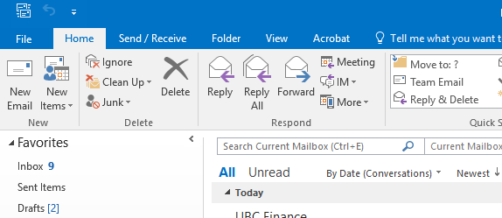Click “File” and then “Options”
2. 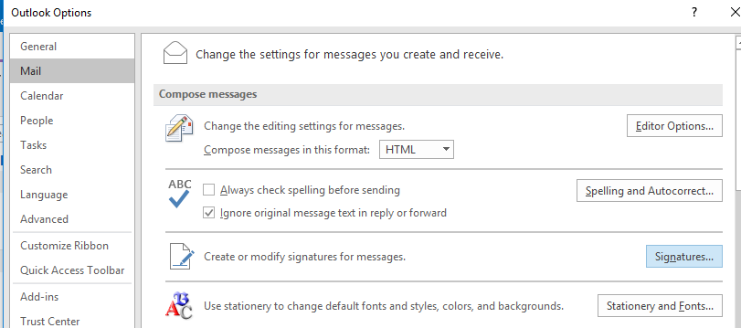Navigate to the “Mail” tab and then click “Signatures”
3. Amend your existing signatures, or create new ones, using the above signature templates. You should have two versions, one long (for new emails) and one short (for replies/forwards).  
     
   Choose the appropriate signature for “New messages” and “Replies/forwards”  
     
   Click “OK” when finished

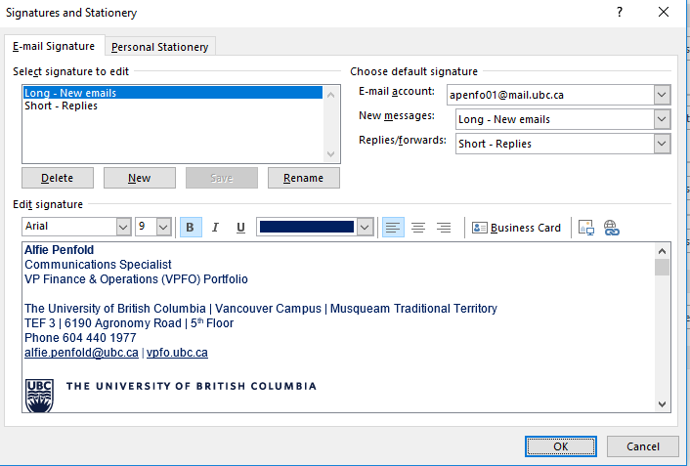

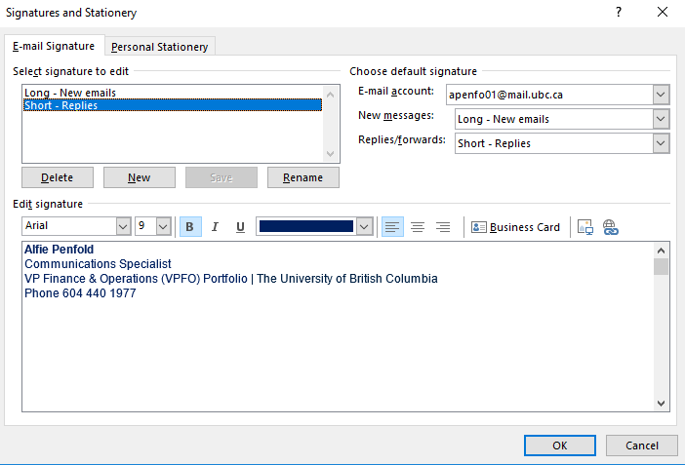

## Guidance — iPhone Mail app

For guidance on how to set up an email signature on an iPhone head to the second section of the below article “How to create rich HTML signatures on your iPhone and iPad”.

<https://www.imore.com/how-to-set-custom-email-signatures>

If you have difficulty using the above guides or use different devices or software and need guidance, please contact Alfie Penfold.

## Guidance — other devices and email applications

Not all email applications and mobile devices allow you to create what is know as a “rich HTML signature”, a signature that includes text formatting like the templates above.

If you use one of these devices or applications, e.g. Gmail, then send yourself an email with your new signature included. Copy your signature, head to settings, click signature, and then paste the signature as plain text.

